Shannon Lee
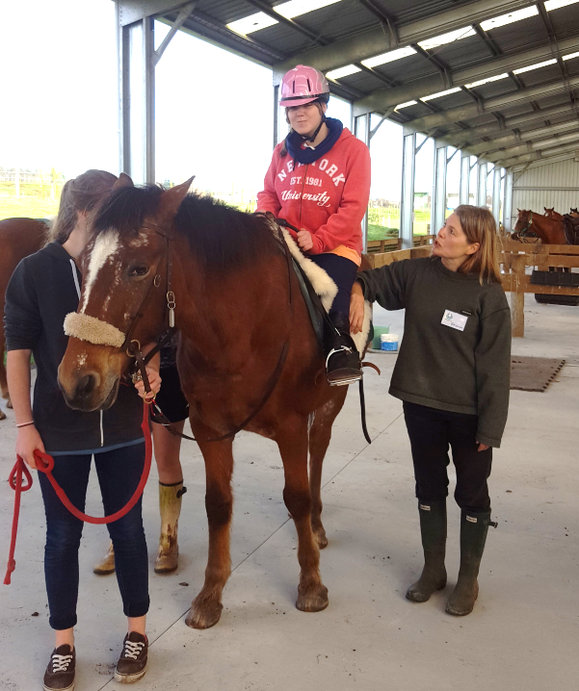
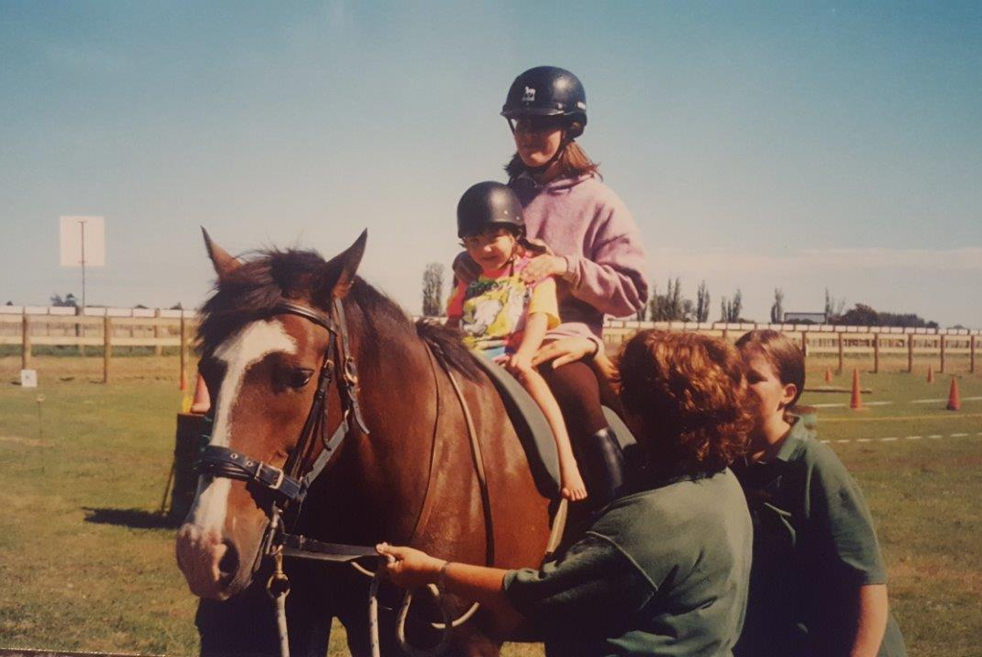

How long have you been riding at RDA Cambridge? (Mum knows this) Since 4 years old, I’m now 20

What is the name of the horse you ride? "Paddy"

How often do you ride? "One day every week"

What do you like about riding your horse? ”I am proud of myself”

What do you especially like doing on the horse? (games, dressage, farm trek, A&P Show) "Galloping"

Is horse riding good for your body? Nod for Yes

If so what parts? Held up Hands Mum adds – Shannon has severe scoliosis, Horse riding strengthens Shannon’s body core. It also helps all her leg muscles.

Do you have a special Coach? Yes. Mum adds – The coaches work with Shannon & her horse to make her work had, her balance, and motor skills get a great workout
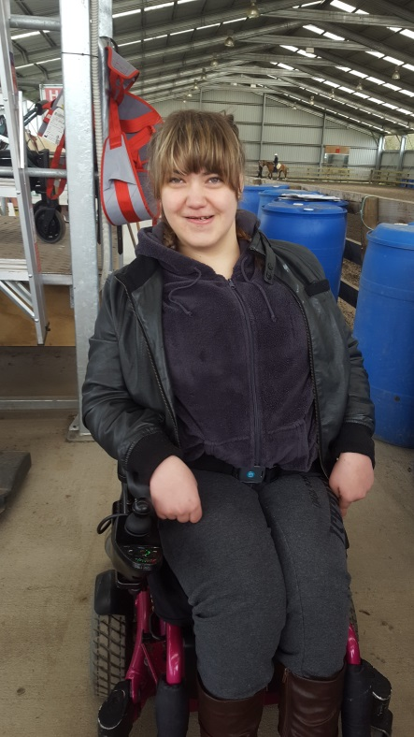
What do you think of all the helpers (volunteers ) at RDA? Gave Thumbs up - They are AWESOME

Anything else you would like to add? "Fun"

