I like riding Toby. Toby goes neigh that’s the sound he makes.
I enjoy seeing myself in the mirror at horse riding.
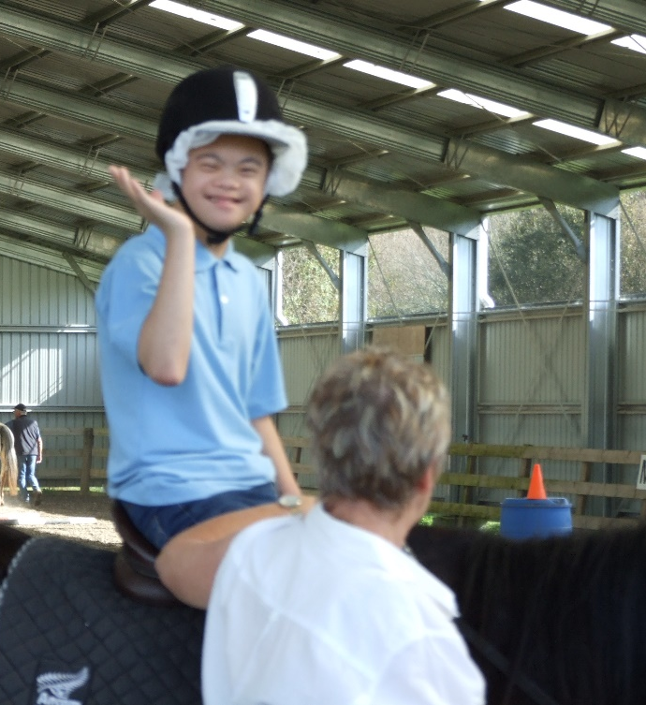
simon

