The horse I like to ride is Bandera.
Bandera and I walk together.

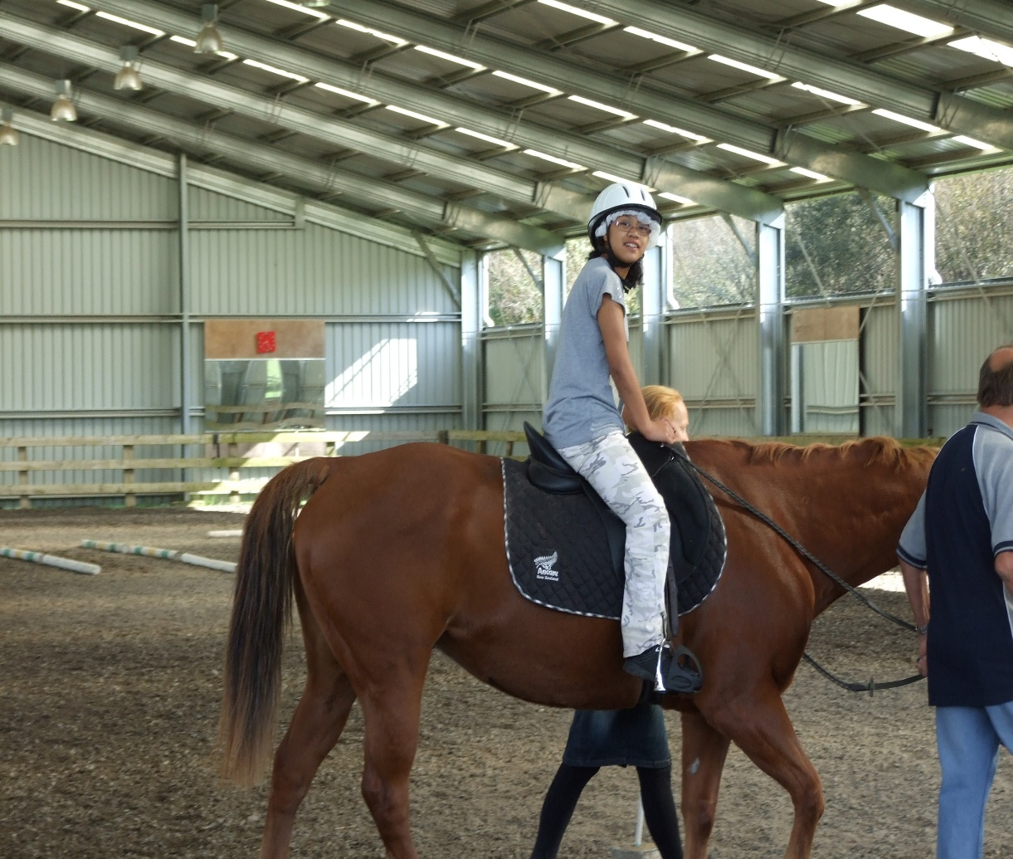

(Marama)

